


AWS Solution Architect Training with AWS Cloud Practitioner Global Certification
Capstone Projects

Trainer: Aravindraj.G- Nminds Academy
AWS Academy Certified Educator



Configure Elastic IP Address to Windows Web Server in AWS


Gokul.S

Objective

An Elastic IP (EIP) in AWS is a static, public IP address designed for dynamic cloud computing. It is associated with your AWS account and can be quickly associated or disassociated with any EC2 instance in your account. This feature is particularly useful when you need to maintain a consistent IP address for your resources, even when you stop and start EC2 instances.

Common Use Cases for Elastic IP:
- Highly Available Applications:
  - If you're running a service that requires high availability, you can use Elastic IPs to quickly reassign a static IP to a new instance if your primary instance fails, ensuring minimal downtime.
- Web Servers:
  - If you host a website and need to ensure the IP address remains the same even if the underlying EC2 instance is restarted, an Elastic IP helps maintain this consistency.
- Disaster Recovery:
  - Elastic IPs are useful for disaster recovery scenarios. If one instance goes down, you can quickly associate the EIP with a backup instance to ensure services are still accessible.
Best Practices:
  - Use Elastic IPs only when necessary: Since they come with associated costs when unused, it's a good practice to release EIPs that are no longer required.
  - Move IPs during instance failure: Instead of keeping an EIP permanently attached, use it as a failover method, reassociating it to a new instance when needed.
  - Monitor EIP Usage: Periodically review your usage to ensure you're not paying for unnecessary Elastic IP addresses.

Topology

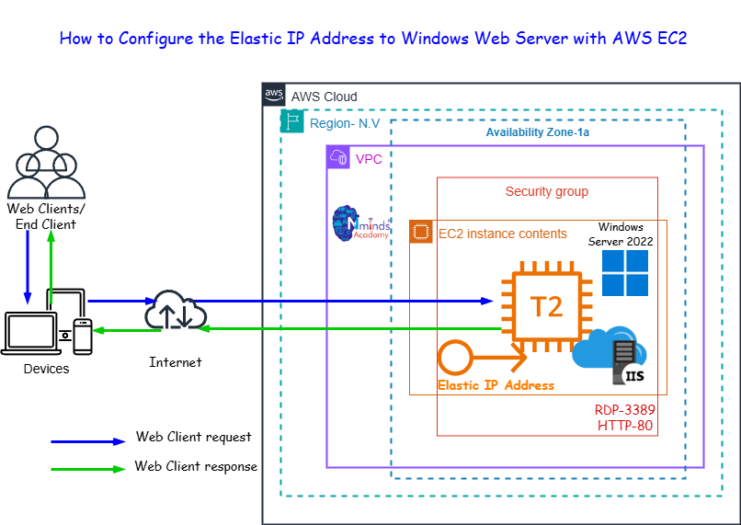

Used Services in AWS Used Services in Windows Server
IIS- Internet Information Services

Amazon EC2

Amazon Elastic IP Address

Execution Tasks:

